RIPHAH INTERNATIONAL UNIVERISTY ISLAMABAD


LAB # 11
SUBMITTED TO : Mam hasnat
SUBMITTED BY: Fatima nazir 45317

TASK 1
#include <iostream>
using namespace std;

enum Type { INT, FLOAT };

struct Function {
string name;
Type returnType;
Type params[10];
int paramCount;
};

Function functions[10];
int funcCount = 0;

// declare function
void declareFunction(string name, Type returnType, Type params[], int count) {
functions[funcCount].name = name;
functions[funcCount].returnType = returnType;
functions[funcCount].paramCount = count;

for (int i = 0; i < count; i++) {
functions[funcCount].params[i] = params[i];
}

funcCount++;
}

// check function call
void checkCall(string name, Type args[], int count) {
bool found = false;

for (int i = 0; i < funcCount; i++) {
if (functions[i].name == name) {
found = true;

if (functions[i].paramCount != count) {
cout << "Error: wrong number of arguments in " << name << endl;
return;
}

for (int j = 0; j < count; j++) {
if (functions[i].params[j] != args[j]) {
cout << "Error: parameter " << j + 1 << " type mismatch in " << name << endl;
return;
}
}

cout << "Function call to " << name << " is OK" << endl;
return;
}
}

if (!found) {
cout << "Error: function " << name << " not declared" << endl;
}
}

int main() {
Type params1[] = {INT, FLOAT};
declareFunction("add", INT, params1, 2);

Type call1[] = {INT, FLOAT};
checkCall("add", call1, 2); // OK

Type call2[] = {FLOAT, FLOAT};
checkCall("add", call2, 2); // Error

Type call3[] = {INT, INT};
checkCall("sub", call3, 2); // Error

return 0;
}
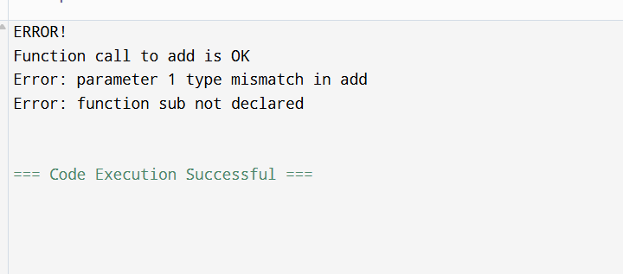
TASK 2
#include <iostream>
using namespace std;

enum Type { INT, FLOAT };

struct Array {
string name;
Type baseType;
int size;
};

Array arrays[10];
int arrCount = 0;

// declare array
void declareArray(string name, Type baseType, int size) {
arrays[arrCount].name = name;
arrays[arrCount].baseType = baseType;
arrays[arrCount].size = size;
arrCount++;
}

// check assignment to array element
void checkAssignElem(string name, int index, Type valueType) {
bool found = false;

for (int i = 0; i < arrCount; i++) {
if (arrays[i].name == name) {
found = true;

// bounds check
if (index < 0 || index >= arrays[i].size) {
cout << "Error: index " << index << " out of bounds (size "
<< arrays[i].size << ")" << endl;
return;
}

// type check
if (arrays[i].baseType != valueType) {
cout << "Error: type mismatch in assignment to " << name << endl;
return;
}

cout << "Assignment to " << name << "[" << index << "] is OK" << endl;
return;
}
}

if (!found) {
cout << "Error: array " << name << " not declared" << endl;
}
}

int main() {
declareArray("scores", INT, 5);

checkAssignElem("scores", 2, INT); // OK
checkAssignElem("scores", 5, INT); // Out of bounds
checkAssignElem("scores", 0, FLOAT); // Type mismatch
checkAssignElem("marks", 1, INT); // Not declared

return 0;
}
